System Downtime Tip Sheet
- Locate 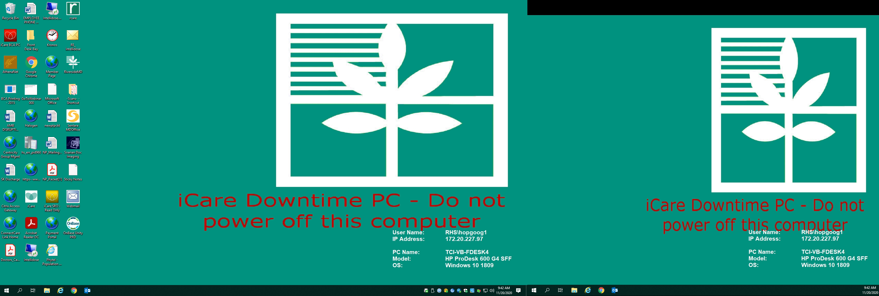 icon and login using KRONOS/iCare username and password
- Upon login note the prepopulated boxes on the left side of your screen as it should reflect your departments at your location, see picture below
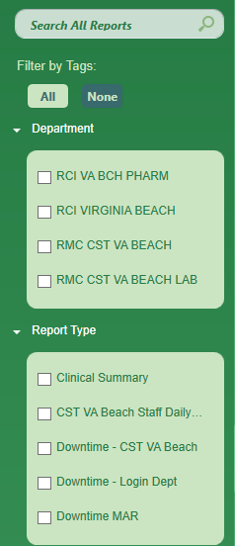
- There are 5 Report Types
  - Clinical Summary Report
    - Patient Name, DOB, Allergies, Problem list, Medication list
    - Treatment plan information
      - Cycle and Day
      - Appointment Requests
      - Labs
      - Nursing Orders
      - Chemotherapy Orders
      - Therapy Plan Current Orders
See example pictured below – best report for MA/lab to room and for infusion RNs
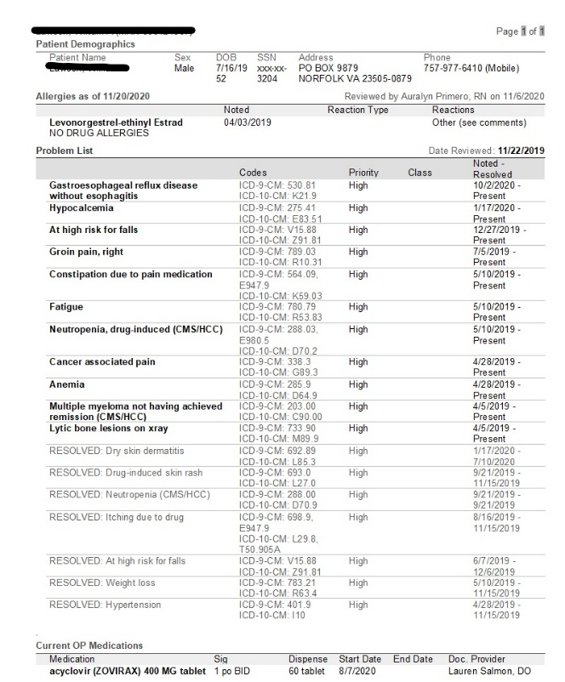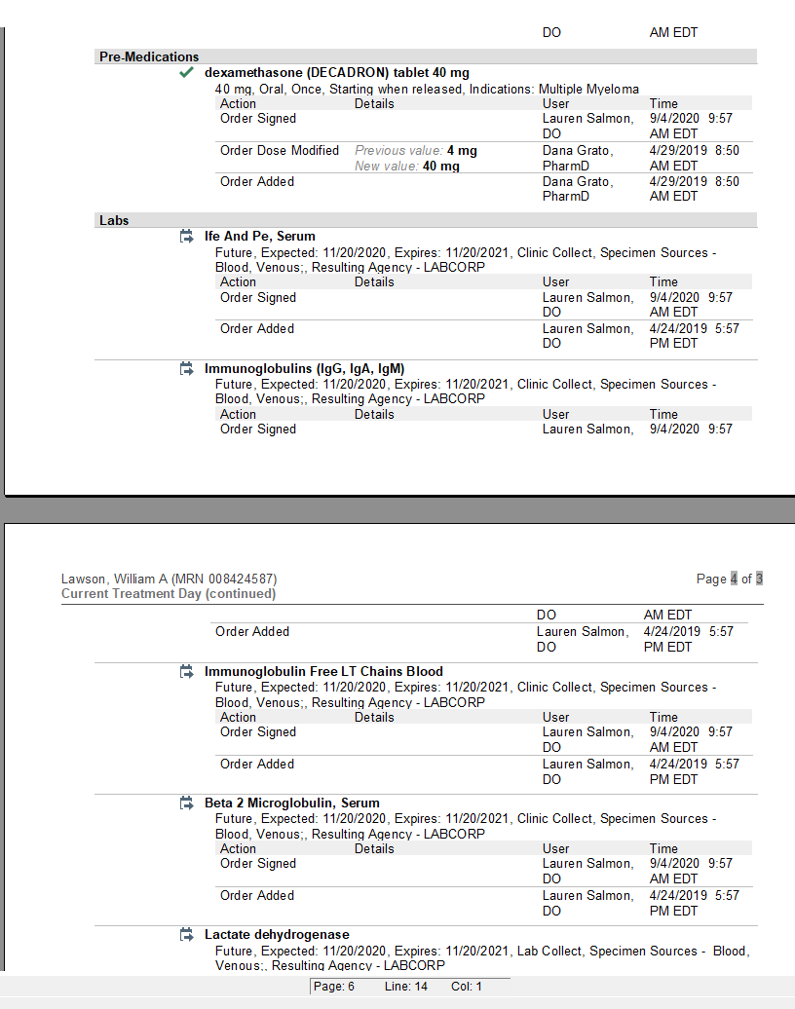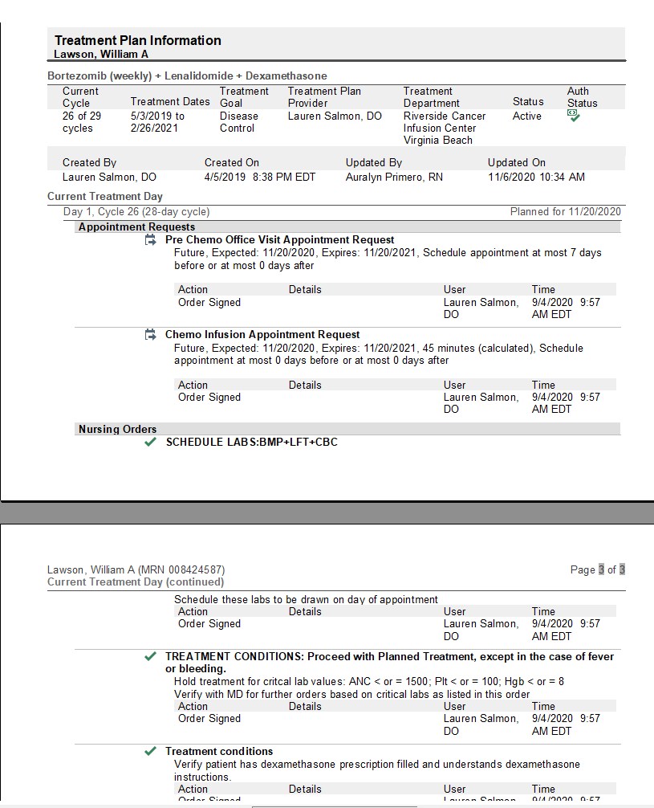

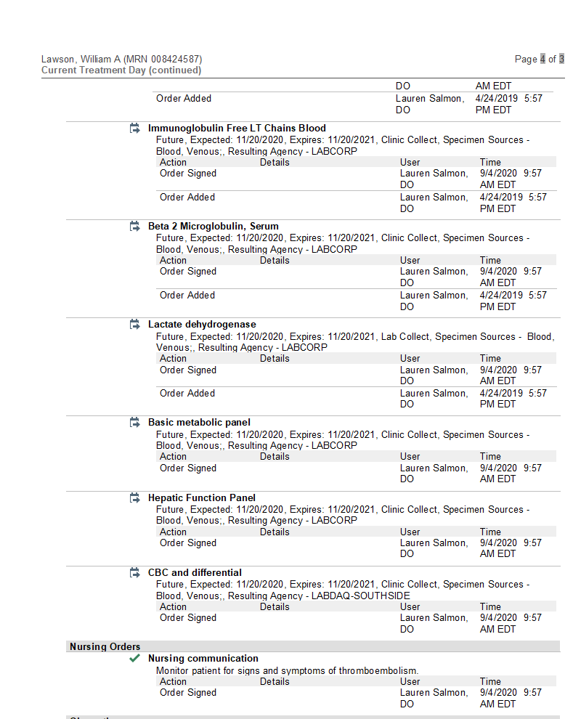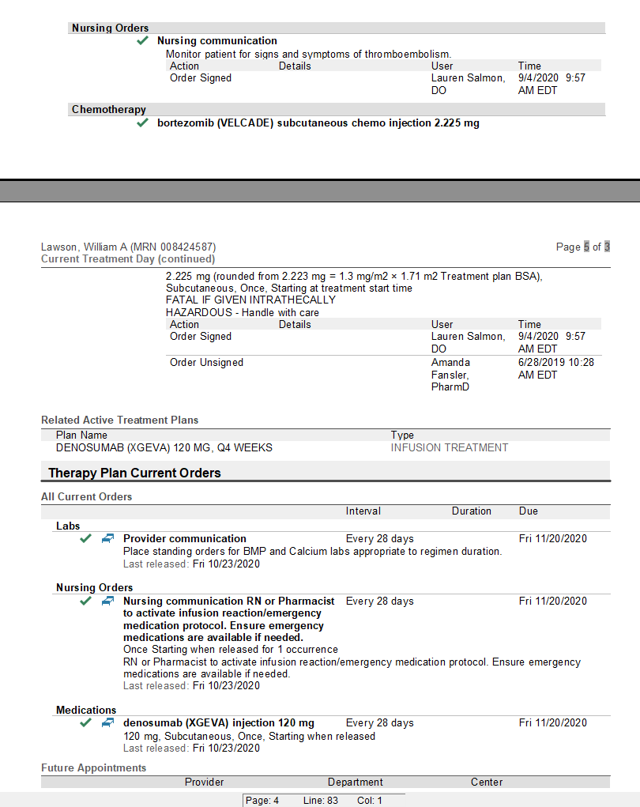

  - CST VA Beach Staff Daily Report
    - Includes the days schedule
    - All Providers who come to your practice show up on here even if they are not at your location that day
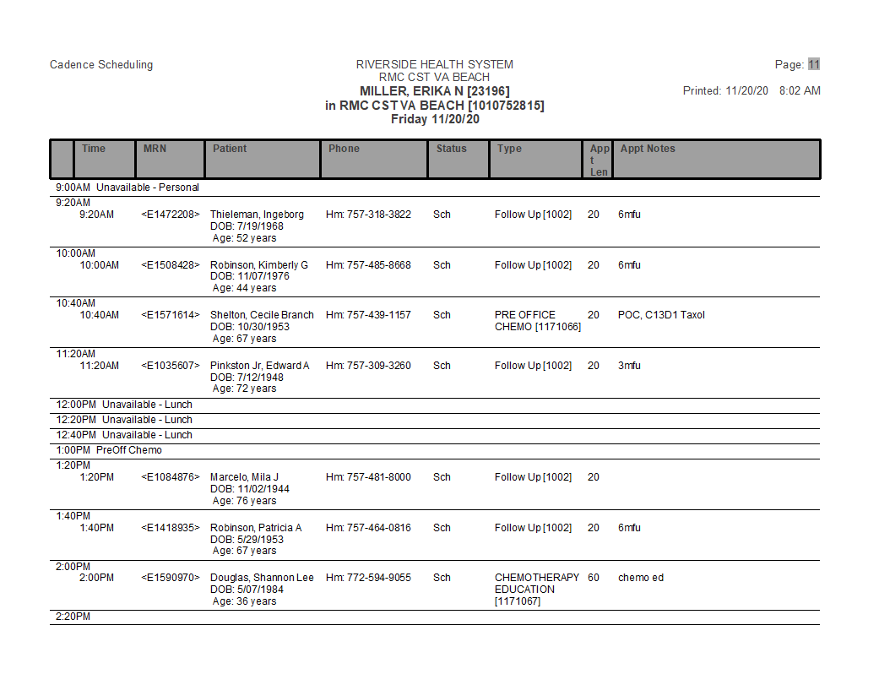

  - Downtime – CST VA Beach
    - Department Appointment Report prepopulated and combines infusion, lab and MD side
    - Workflow for front desk and verifying coverage
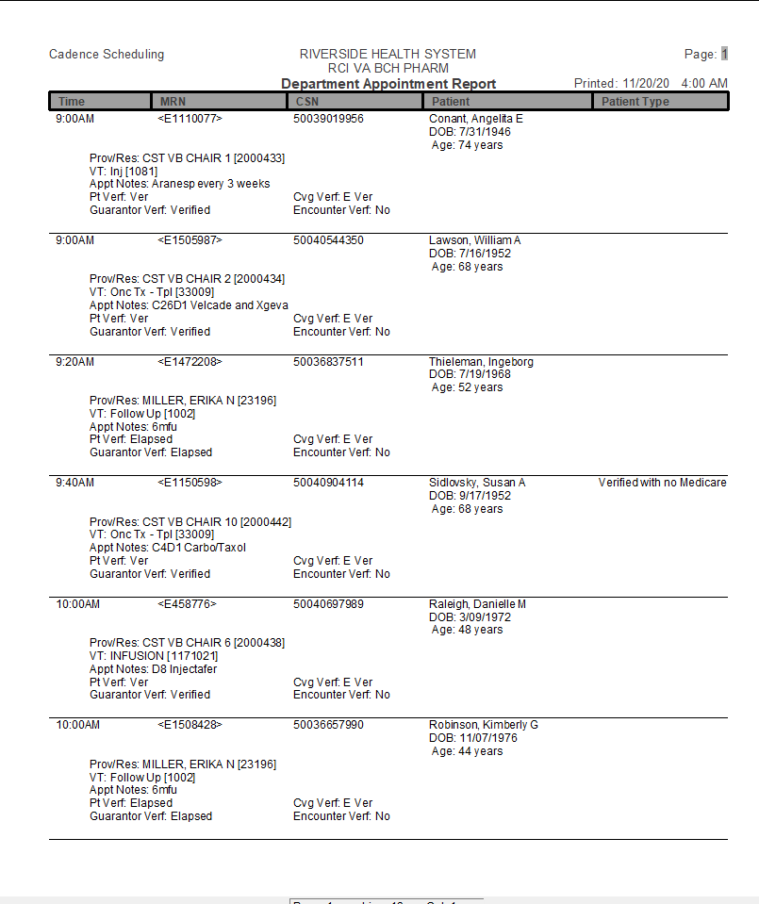

  - Downtime – Login Dept
    - Department Appointment Report can filter between three departments
    - Workflow for front desk and verifying coverage

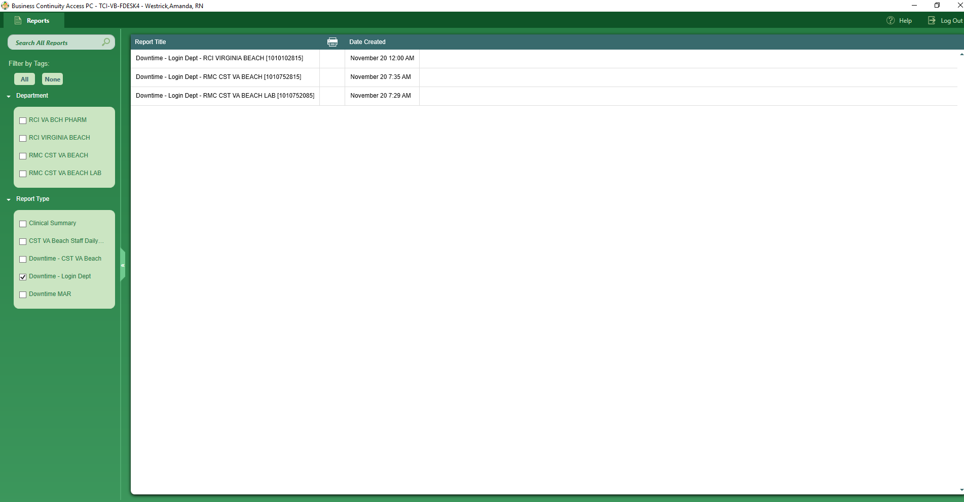

  - MAR
    - Shows medication due times/administration times if you have released from treatment plan/therapy plan and documented prior to system going down otherwise the document is blank
See below for pictures of both (Left is once released; Right is prior to orders being released)
