**How to get to Elsevier Clinical Skills**

Go to the Riverside Intranet

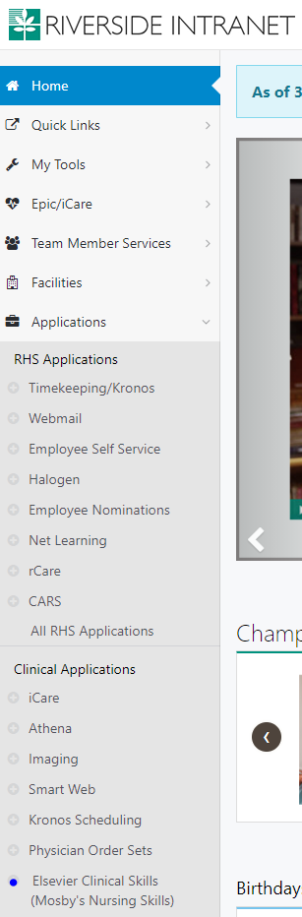Under Applications—Click Elsevier Clinical Skills

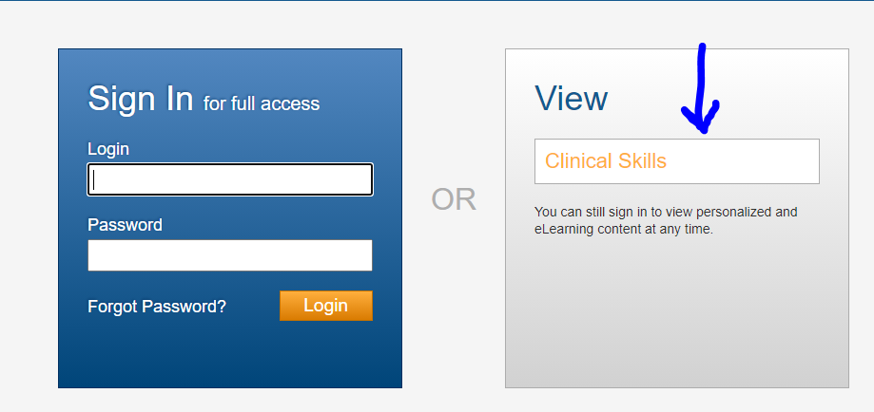No need to Sign in. Click on Clinical Skills

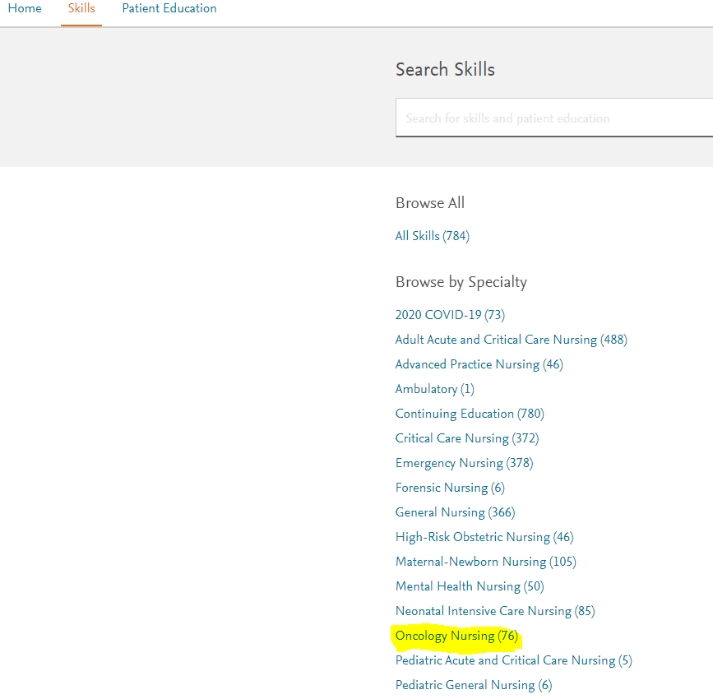Click on Oncology Nursing

*It will bring up 76 Oncology specific modules. There is clinical skills tip sheets, some have videos, and patient education.